- Write a JavaScript program to find the number of sorted pairs formed by its elements of an given array of integers such that one element in the pair is divisible by the other one.
For example - The output of [1, 3, 2] ->2 - (1,3), (1,2).
The output of [2, 4, 6] -> 2 - (2,4), (2,6)
The output of [2, 4, 16] -> 3 - (2,4), (2,16), (4,16)
- Write a JavaScript program to check if a given matrix is an identity matrix.
Note: In linear algebra, the identity matrix, or sometimes ambiguously called a unit matrix, of size n is the n × n square matrix with ones on the main diagonal and zeros elsewhere.
[[1, 0, 0], [0, 1, 0], [0, 0, 1]] -> true
[[1, 0, 0], [0, 1, 0], [1, 0, 1]] -> false
- Write a program to create a calculator
- Write a program to sort an array
Arr=[1,4,2,3]
- Write a program to reverse the sorted array
- Write a JavaScript program to display the current day and time
- Write a program to change the text if user log out
- Write a JavaScript program to determine whether a given year is a leap year
- Write a JavaScript program to calculate multiplication and division of two numbers
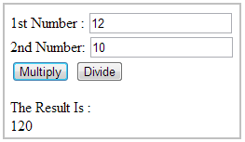
- Write a JavaScript program to compute the sum of the two given integers. If the two values are same, then returns triple their sum.

